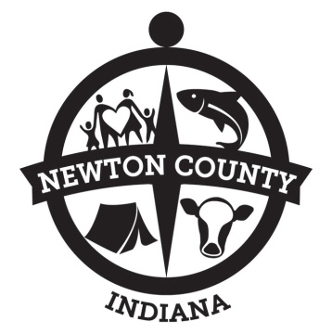
Newton County Board of Commissioners

Newton County Government Center
December 20, 2021
3:00 P.M.

- Call Meeting to Order
- Pledge to Flag – Jacob Shufflebarger
- Approve Meeting Minutes – Executive Sessions 9/29/21 &10/4/21; Special Meetings 9/29/21 & 11/15/21; Regular Meetings 10/4/21, 10/18/21, 11/1/21 & 11/15/21
- Approve Payroll/Longevity – 12/23/2021
- Approve Claims – 12/20/2021
- Department Heads/Elected Officials
- OLD BUSINESS
- Ordinance Book
- Landfill Tipping Fee
- Wind/Solar Ordinance
- Event Ordinance
- NC Fair Grounds – Sewer Project
- NEW BUSINESS
- Board Appointments
- Request for Extension of PTO
- Other Matters
- County Attorney
- Public Comments
- Adjournment

APPOINTMENTS:
3:10pm – Apex; Alma Shireman – Clinic plans

Next Commissioners’ Meeting is Thursday, December 30, 2021 at the Courthouse
Next Council Meeting is Friday, January 17, 2022 at the Government Center

Kyle D. Conrad ∙ Tim Drenth ∙ Butch Cain

